
Land Information Ontario (LIO) Warehouse
Data Class Name: Species Occurrence, Provincially Tracked
Documentation
Produced by: Information Access and Information Management Policy Unit
Ministry of Natural Resources and Forestry
Date: July 27, 2015

Purpose

This document provides additional information to support the use of geospatial data. The Physical Model Diagram provides a visual representation of the relationships in the data class. The Data Change History lists all the modelling and access changes that have occurred during the lifecycle of the data class. A data description identifying table and field names is available upon request.

Need Assistance?
Please contact LIO Support at lio@ontario.ca or 705-755-1878 if you require help.

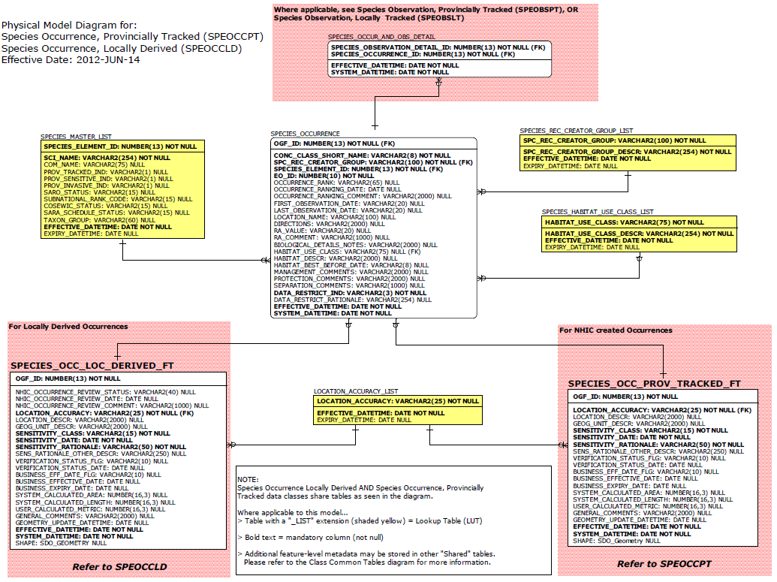

Data Class Change History

Data Class Name: Species Occurrence, Provincially Tracked
Data Class Short Name: SPEOCCPT
Date  YYYY-MM-DD | Details of Change
2011 | Significant model redesign of layer to reflect current Natural Heritage Information Centre (NHIC) business area requirements. Affected data classes include:  - Species Observation, Locally Tracked (SPEOBSLT)  - Species Observation, Provincially Tracked (SPEOBSPT)  - Species Occurrence, Provincially Tracked (SPEOCCPT)  - Invasive Species Occurrence (INVSPOCC)
2008 | Data maintenance process and protocol updated.
1999 | NEW Data Class
Data Description
Please refer to the metadata record for the data description.

